**Worksheet-2.2**

**Student Name:-** Pushpraj Roy **UID:-** 20BCS9866

**Branch:-** BE- CSE **Section/Group:-** WM_617 “A”

**Subject Code:-** 20CSP-338 **Semester:-** 5th

**Subject Name:-** Web and Mobile Lab

1. **Aim/Overview of the practical:**

Perform Penetration testing on a web application to gather information about the system (Foot Printing).

1. **Steps with Screenshots:**

* 1. So, first we are doing penetration technique on a spam email.

* + We will use a tool named IP WHO IS LOOKUP for it.
  + The first step is to open any mail from junk of our Gmail. For eg- I have taken this mail.

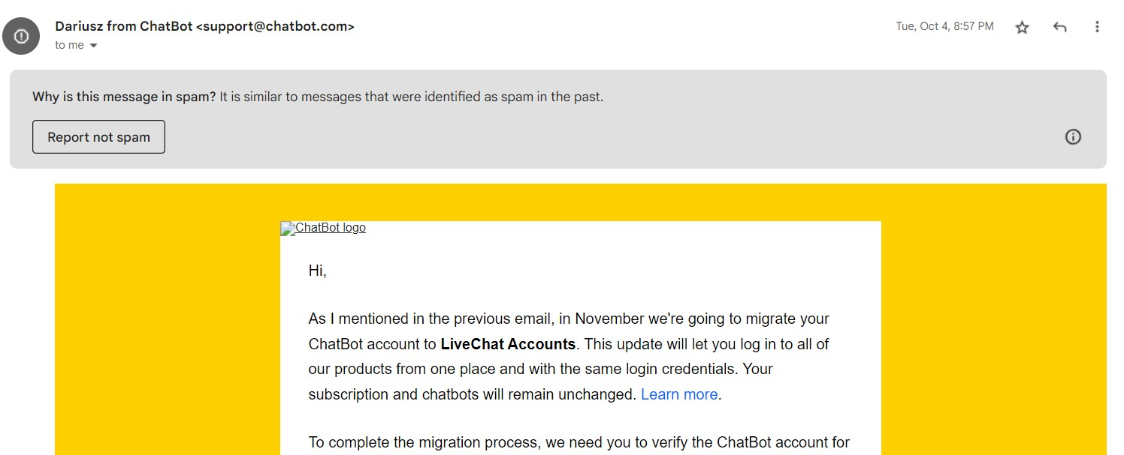

* + Now, we will select the three dots on right corner and select show original.
  + Then we will get directed to the following page:

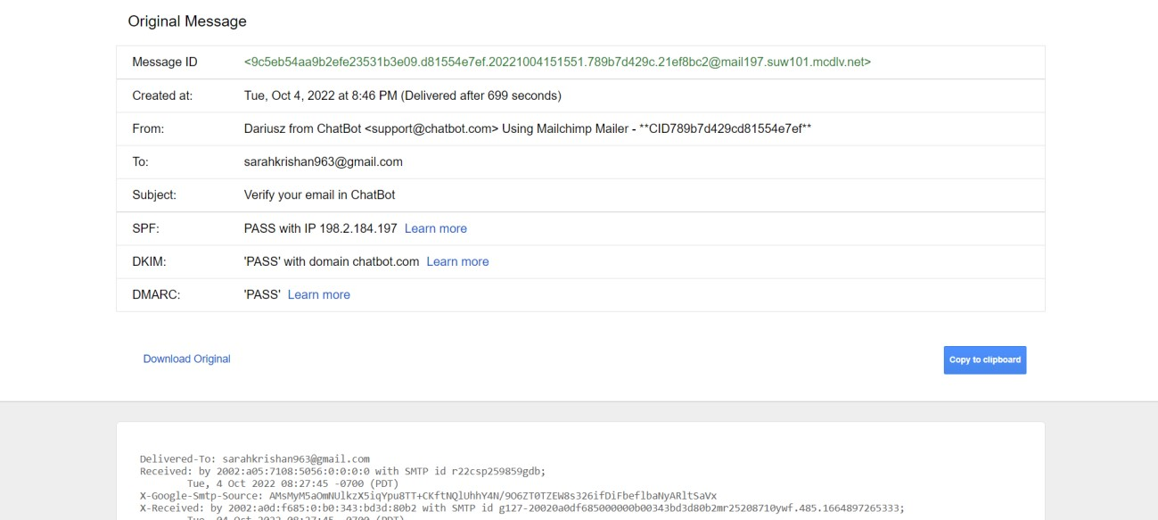

* + We have to search the word received on this page and then copy the ip address from there.

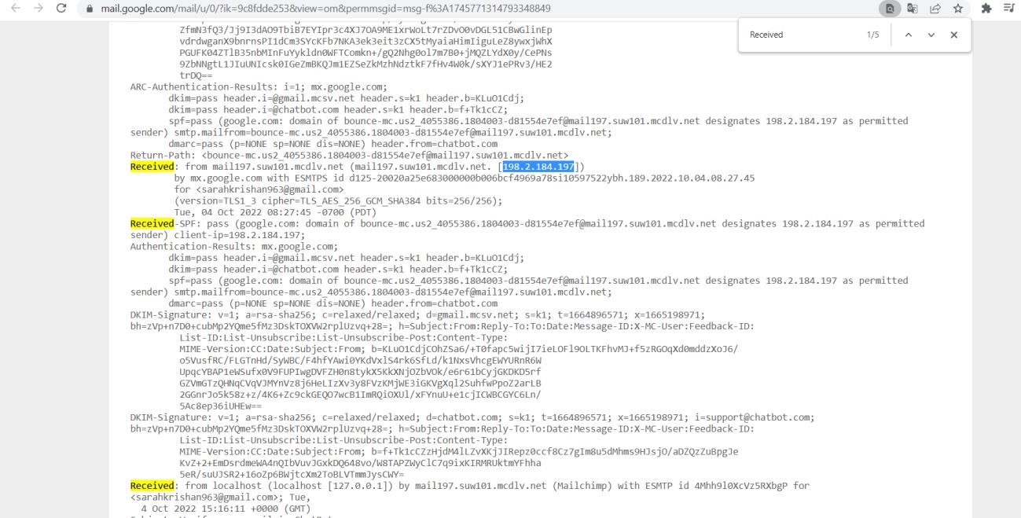

* + Then paste this IP address to IP WHOISLOOKUP tool and press lookup.

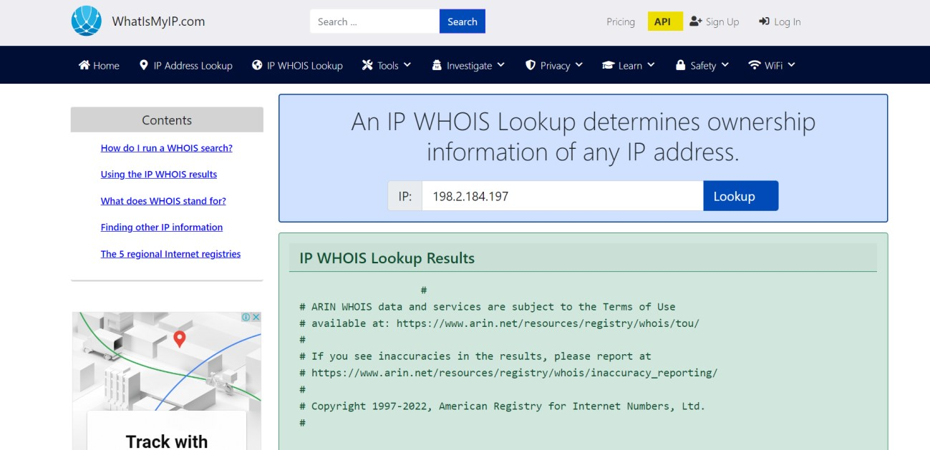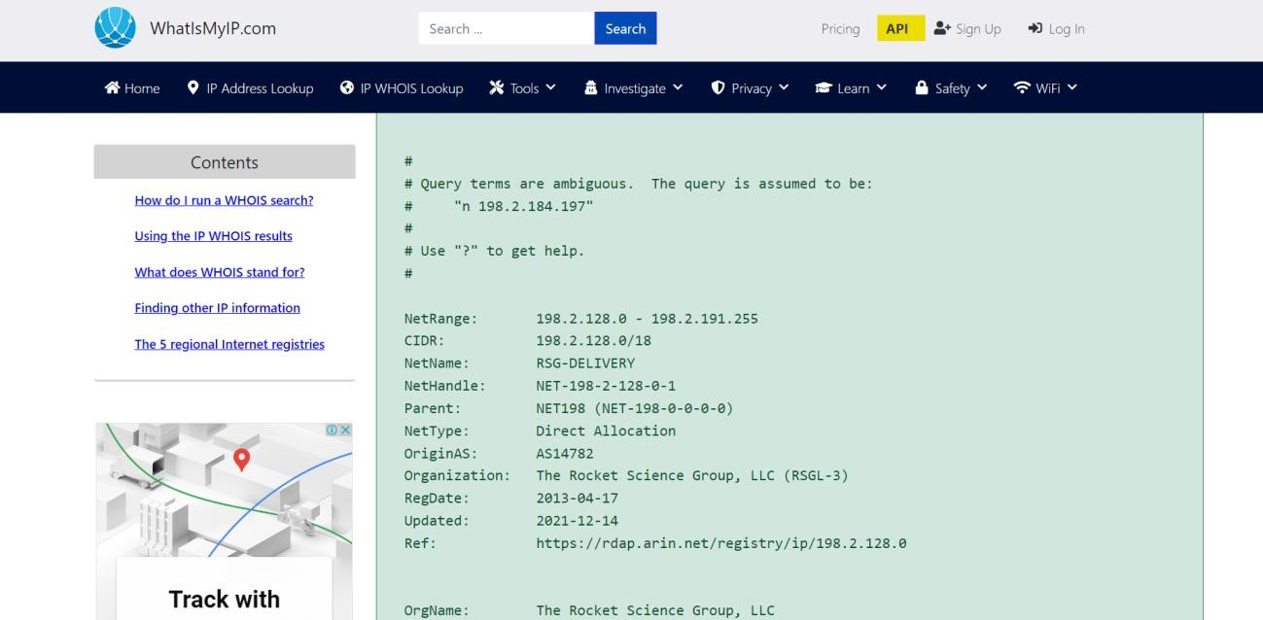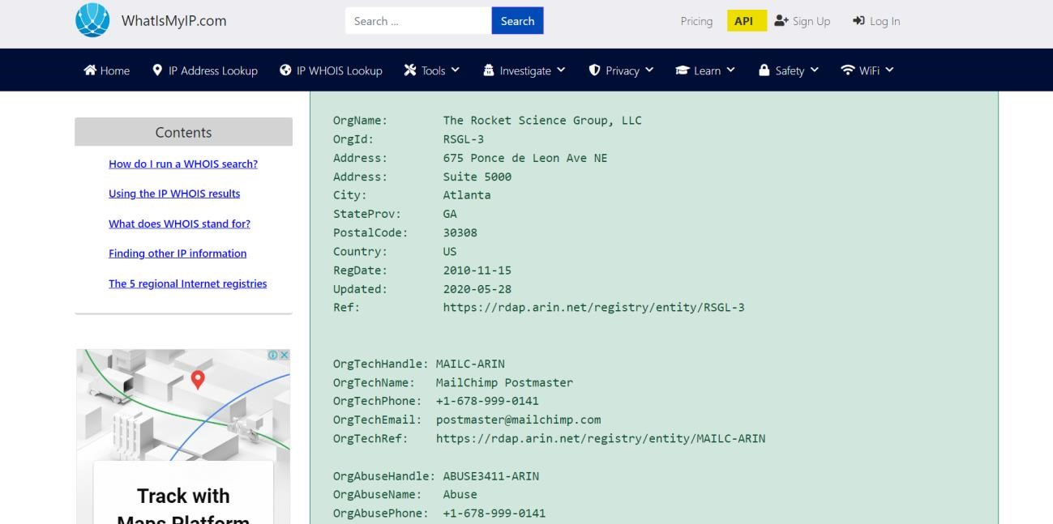

* 1. **Now, the second tool we going to use is CentralOps.net, this tool will tell us about websites including their name servers and IP addresses. We will be checking this on three different websites.**

* + The first web-site we will be penetrating is [www.google.com](http://www.google.com/)

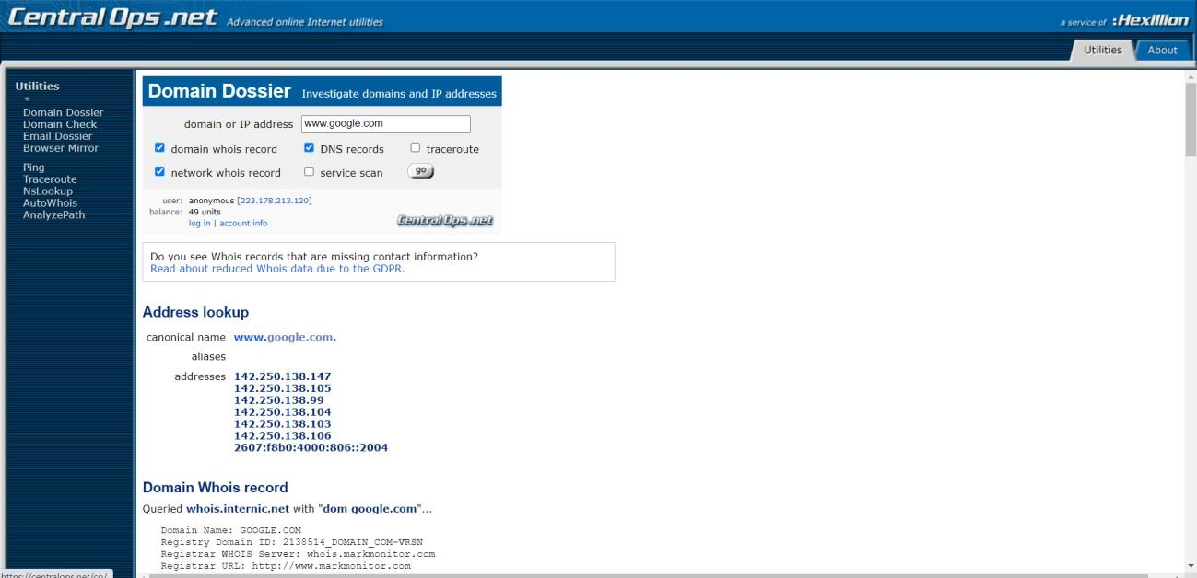

* + We can see the four name servers of google in the fig below:

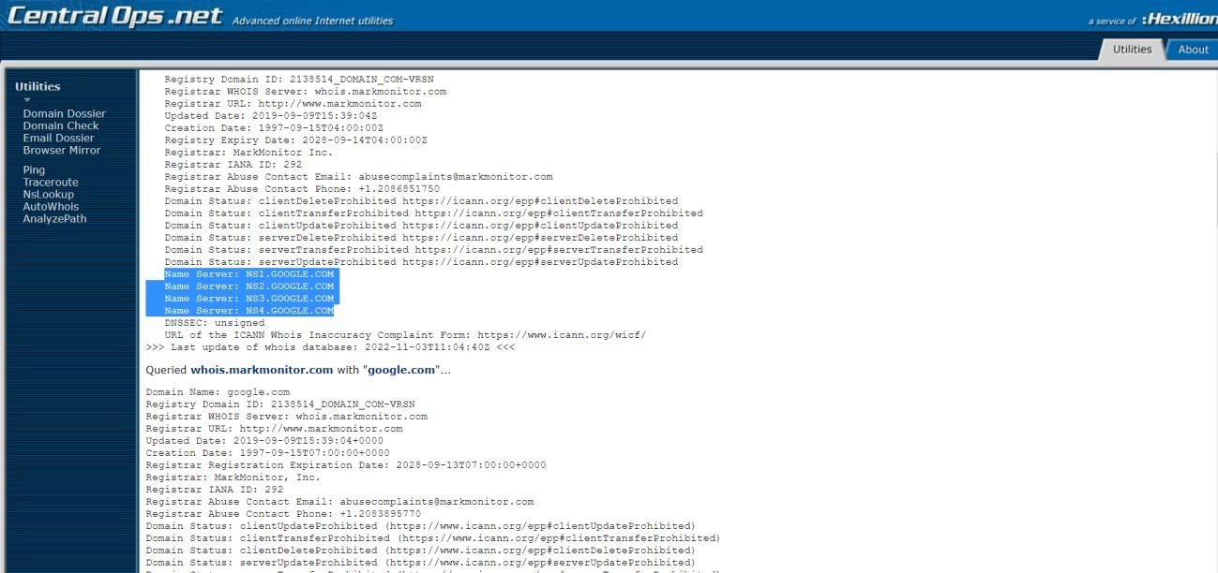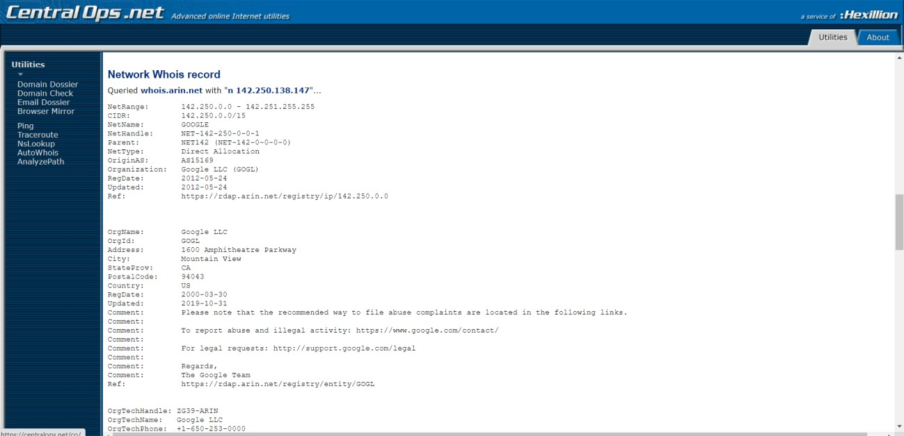

* + We can even find the class of an IP address by looking at its IP address.

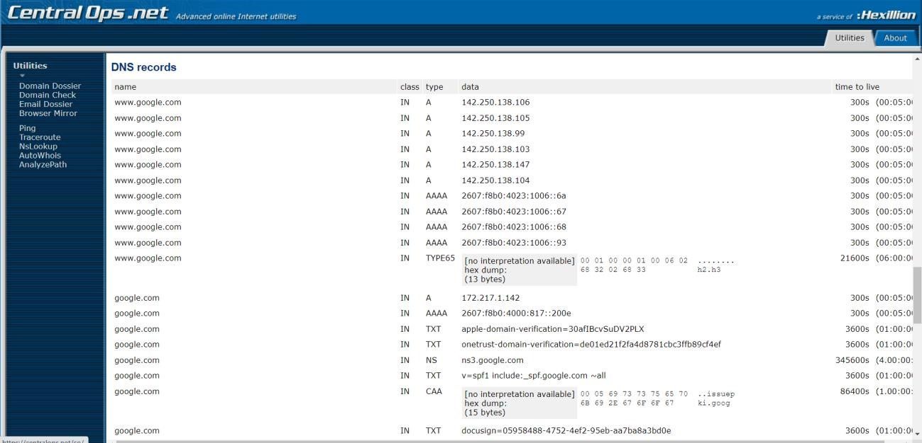

* + **The same now checking for Netflix.com**

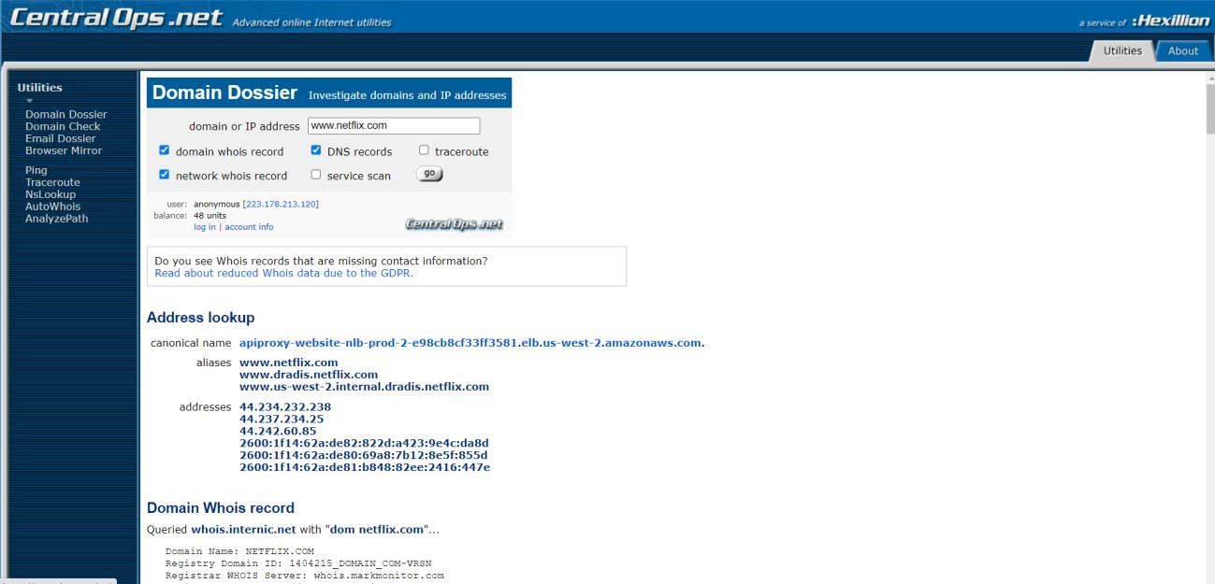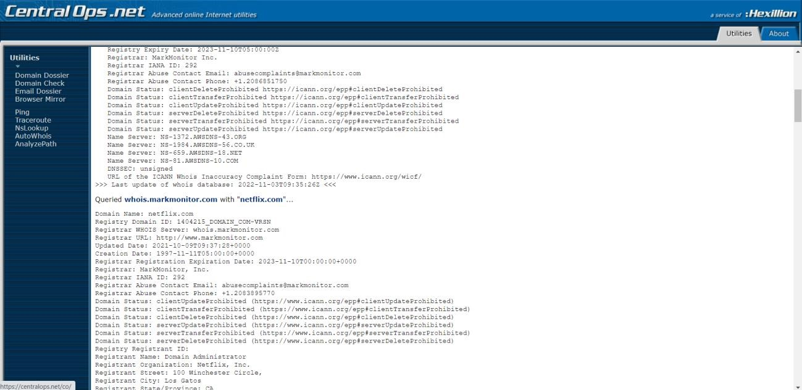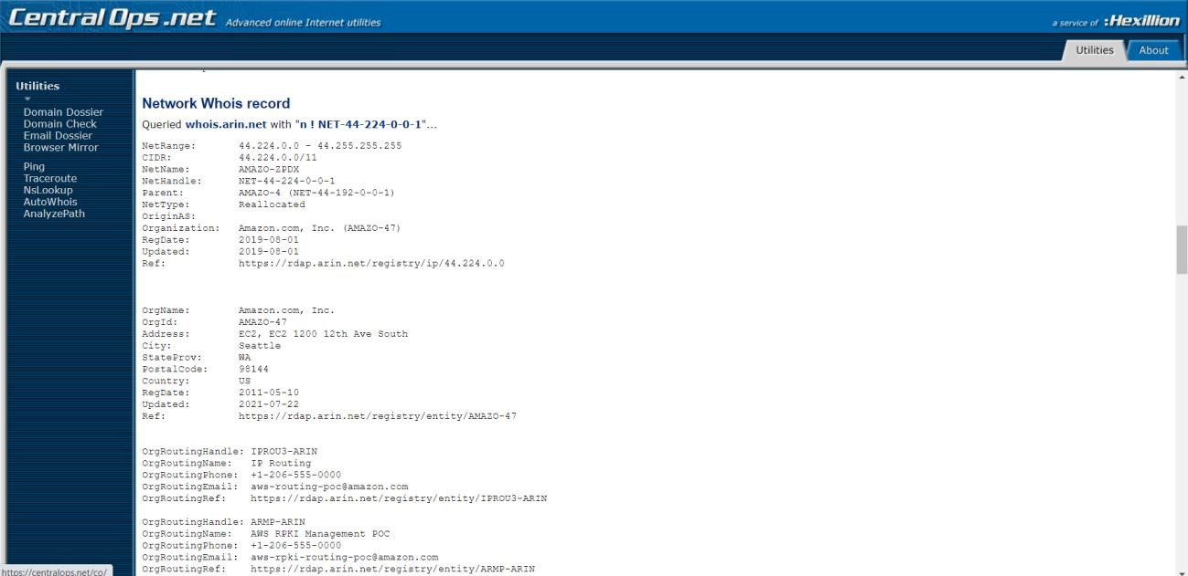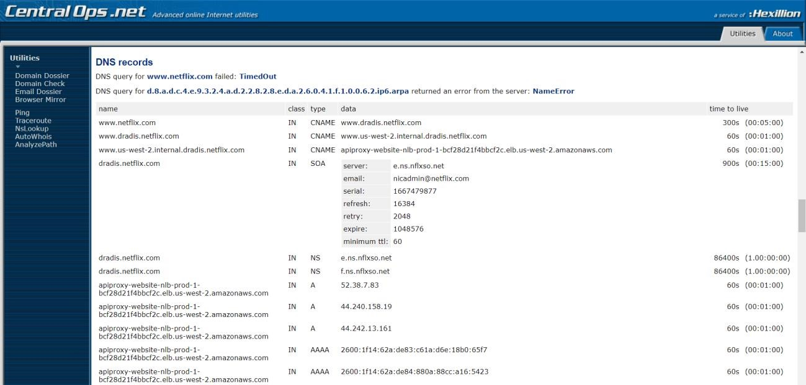

* + **At last, now we are checking for twitter.com**

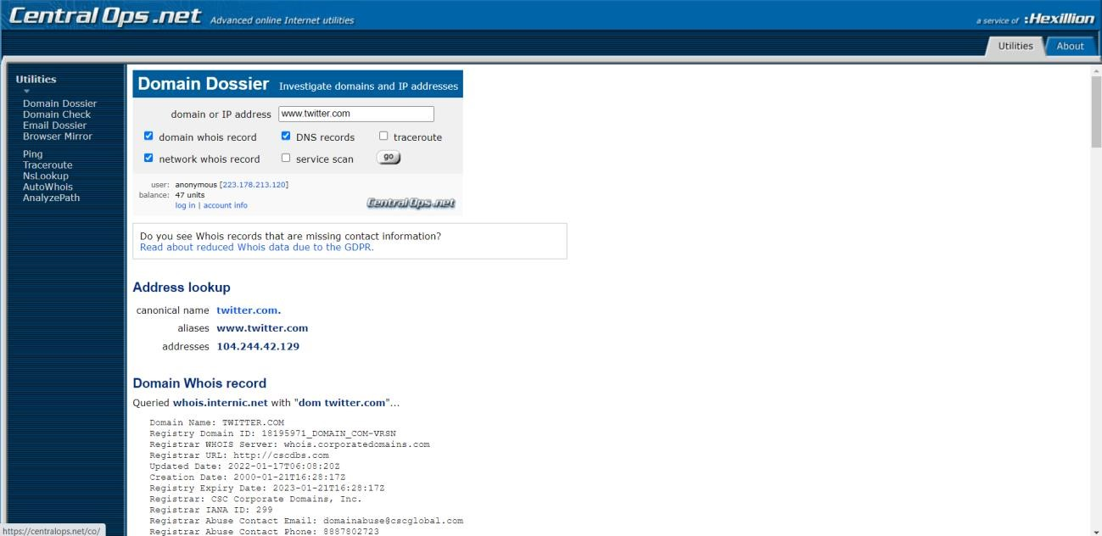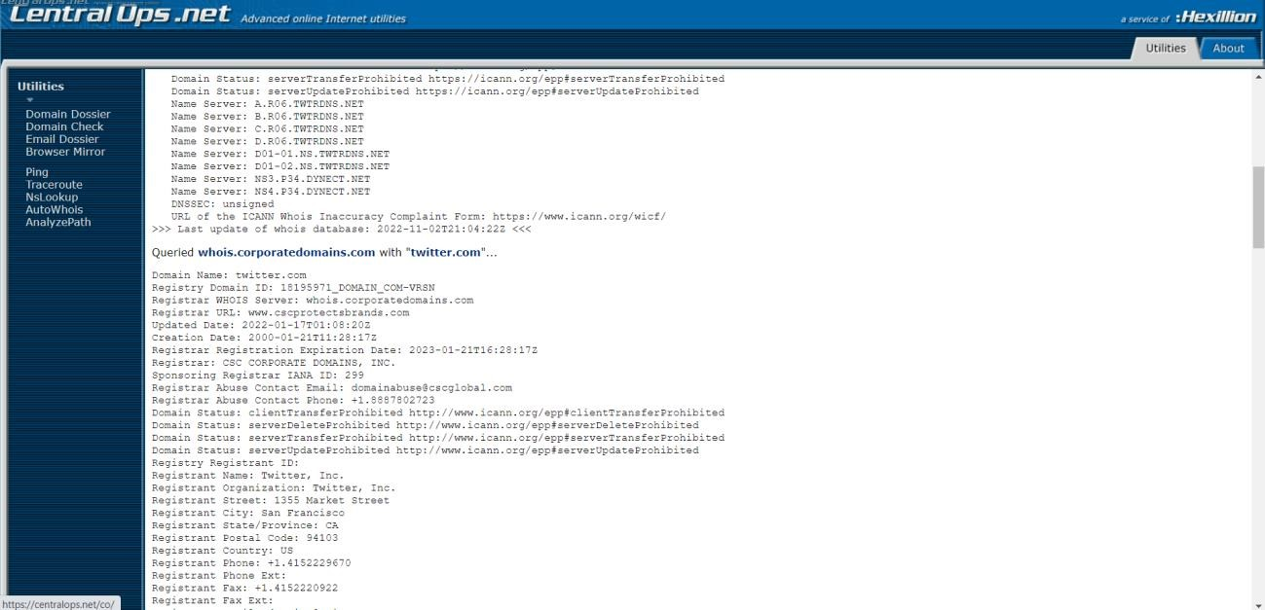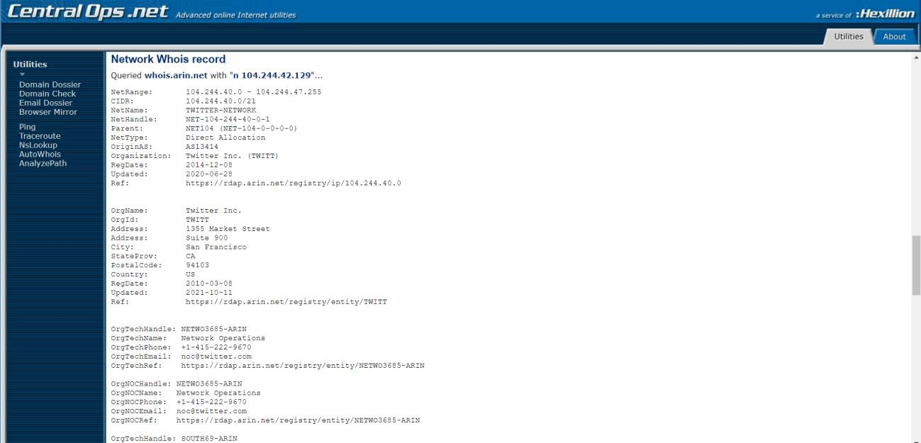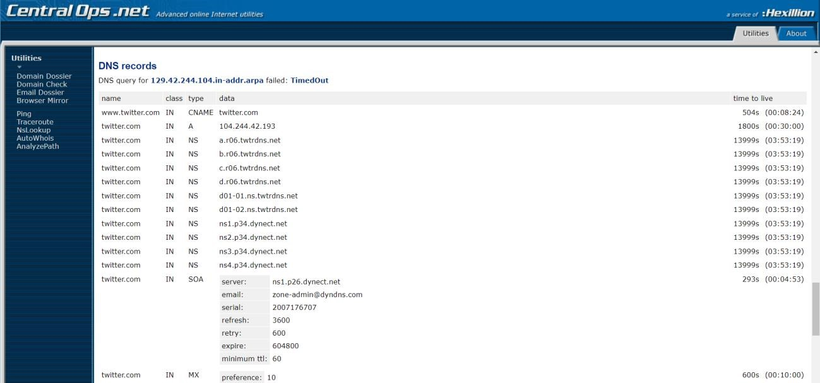

**Learning outcomes (What I have learnt):**

* + 1. **Learnt about different penetration techniques.**
    2. **Learnt about E-Mail and web-site penetration techniques.**
    3. **Learnt about name servers and different classes of IP addresses.**

# COMPUTER SCIENCE & ENGINEERING